Stefanie Parisi
LIT 241
December 7, 2019

A Logo for Inferno and Its Elements Explained

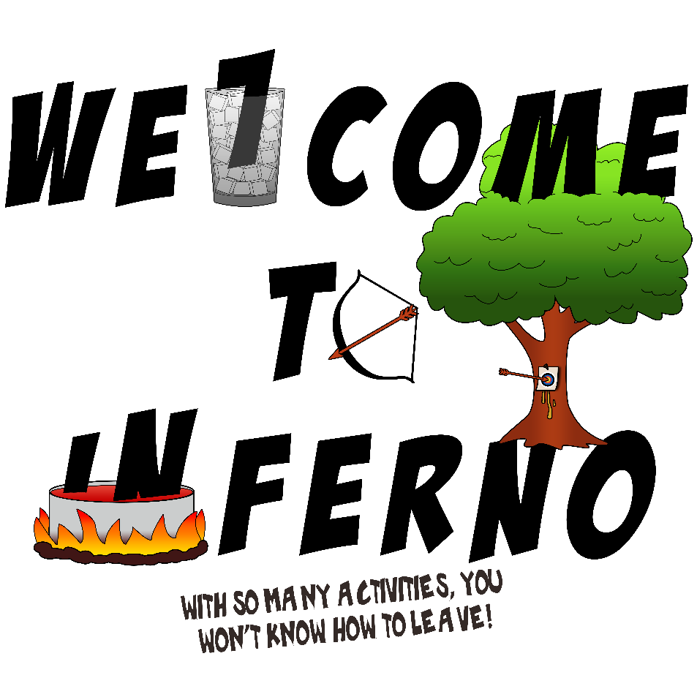
A modernized logo, Figure 1, of Inferno from Dante’s La Commedia was made in a comic style to cover up the heinous contrapasso the souls experience. Since the majority of the souls believe they do not belong in Inferno, I wanted to make the elements of torture pleasing. I did this through making Inferno appear to be a summer camp full of activities: making food – specifically soup-, learning archery, and getting sap from trees. There is a glass of ice in case of injury or if it gets too hot. The “WELCOME TO INFERNO” font, BadaBoom BB, was chosen as its block letters give an inviting style and comic feel to it. The upside-down “L” resembles a “7” and a straw better than most other comic style fonts. The slogan’s font, Roof Runners Active, was chosen for its slight “slap” style on the “N”. The letters are thinner to not take away from the other font. The letters have varying thickness and are asymmetrical making it feel imperfect. This gives the viewer an unsettled feeling without them directly noticing.

Figure 1. A modernized logo for Inferno maintaining elements from La Commedia.
The first element in the logo is the glass of ice with the upside down “L”. The “L” represents Lucifer and is upside down to represent the confusing orientation Dante describes when traveling from Inferno to Purgatoric in Canto XXXIV of Inferno. The “L” also appears to be a “7”, a number that is mentioned many times throughout La Commedia and can be related to the 7 deadly sins. Using the font BadaBoom BB was the perfect opportunity to showcase this number and what can be expected of the souls after passing through the gate. Inside the glass there is ice around the “L” to relate how Lucifer is stuck in the ice in Inferno. The glass can be seen as a boundary that Lucifer cannot cross as he will always be stuck in the ice. At the opening of the glass, some of the ice cubes are sticking out and some remain in the glass. The ice cubes also represent the sinners who are in this level of Inferno; some with their head out such as Ugolino and others completely submerged. On the glass there is a color gradient of black to white with low opacity and color burn – a means of increasing contrast between the base color and the gradient. This makes the glass appear to be transparent and gray: an eerie color that allows you to visually see what is behind it. The only colors in this area are of Lucifer’s three faces, red, black and yellow. All three of these colors did not mimic the feeling I felt when reading Canto XXXIV. Dante clearly describes everything in the area so black did not seem like a good choice. Yellow and red were too strong in comparison to Dante’s eerie description with limited sounds. As for the gradient, it gives the glass depth to show where Lucifer is in Inferno. The top is not completely transparent which continues to restrict Lucifer in the depths of Hell.
Dante describes that the river Phlegethon is boiling when he wrote that it was a “…vermilion boil…” (Inferno, Canto XII, 101, tr. Hollander). This was the main reason I chose to make a pot of boiling red soup. I also put hot coals at the bottom to tie into the earthy stone that is evident throughout Inferno. Since Dante referred the color of the river as vermilion, the blood in the pot has the vermilion/cinnabar hex code of #e34234. From the “WELCOME TO INFERNO” words, the “I” and “N” are inside the pot at varying levels. I specifically chose to do this with the “IN” part of Inferno because of the quote, “‘Shooting arrows at any soul that rise / Higher from the blood than guilt allows’” (Inferno, Canto XII, 74-75, tr. Hollander). The souls are supposed to be drowning in their guilt which is represented by the blood in the river Phlegethon. Guilt is within the blood so one must be in the amount of blood that corresponds to the amount of guilt in one’s soul. The letters are staggered to show that they have different amounts of guilt just like the sinners in the river. The color of the pot is hex code #cbcdcd which is a generalized code for iron. I wanted the pot to resemble the limitation the souls have in going anywhere while also showing that they are there because of themselves. As iron is in blood, blood contains guilt, and guilt is defining the soul’s punishment’s, I thought an iron pot was well suited for the job.
Arrows are littered throughout La Commedia and used in Canto XII to keep the sinners in the Phlegethon from “….ris[ing] / Higher from the blood than guilt allows” (Inferno, Canto XII, 74-75, tr. Hollander). The bow with the arrow is facing the “N” because it is beginning to rise higher than it should. I chose to make the “O” in “TO” as the bow with an arrow inside because the shape was perfect for a taut bow and the arrow going across resembles a zero with a line through it. The zero represents nothing, not one. As in most modern engineering and math courses the line is to emphasize that it is zero and not to confuse it with something else. This is to really drive the point that no one will escape Inferno, or the Phlegethon as an arrow to the body prevents that activity.
In Canto XIII, the souls who committed violence against themselves or against their possessions are forced to grow into trees in bushes in a murky wood. Trees and bushes are evident in summer camps, so I decided to make a lush tree that was filled with leaves and had a strong trunk. The abundance of leaves correlates to punishment of being forced to live to your fullest potential. This opposes Dante’s description of murky and gives the design a welcoming feel. At the same time, it relays Dante’s message that God gave you a life and you took it for granted. Now you must “live” or grow into a life that you do not have the ability to take life away from. Vegetative life does not have the means to destroy their own possessions or commit suicide. The “ME” in “WELCOME” was placed inside the trees leaves to represent that the souls in this area were only thinking of themselves when committing these acts of violence. Additionally, the trunk of the tree is on top of the “NO” in “INFERNO” to denote that because the souls committed an act of violence, they must now grow from the negative.
When making the tree, I decided to continue with the top down look to match the glass of ice and pot of blood. This was also done to hide the branches of the trees coming from the trunk. I wanted to hide the branches even though Dante talks about the them a lot in Canto XIII because it hides the torture they go through. It also gives the opportunity to represent a more modern view of suicide: the stigma of not reaching out for help when in need. Since I hid the branches, I wanted to find a way to represent the blood that spills when the soul’s branches are broken to keep it consistent with the dogs racing through the branches. I did not want to add a dog or something that was going to be breaking the branches as it would have made the simplicity of the style too complicated. I instead chose to merge the arrows from Canto XII with the tree so that the viewers eyes would be forced to look left, then right, and then overall. I want the viewers eyes to scan the whole design so, using opposing arrows allows for this. I also chose the arrow so that it could pierce the tree and cause sap, related to the blood in the story, to drip from behind the bulls-eye. I added the bulls-eye to cover the “wound” in the tree to maintain the friendly nature of the design. At the same time, it represents that the trees branches are targeted by the dogs to give the souls their contrapasso.

